Neon and Splash Sessions in Worcester
Neon splash painting in Worcester brings together colour, lively movement and UV light in a fun and creative experience. Guests get to throw, flick and splash paint onto a canvas and the neon paint lights up when the lights change. The studio at 2 New Street is open, to everyone whether you are a beginner or someone who has painted before. Protective clothing and all materials are provided on the day. At the end of each session guests leave with a piece to take home.
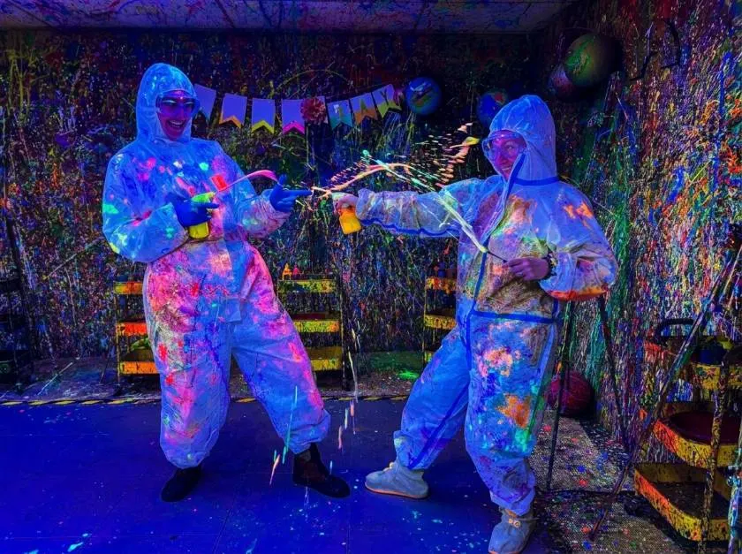

Welcome to Worcester Neon Splash
I find Rage painting Worcester sessions bright and lively a choice when I want something different to do in the city. When guests throw paint across a canvas and they flick it and splash it the rage painting becomes an experience. The neon and splash option adds paint that glows under UV light so the final piece looks striking when the lights change.Rage painting Worcester sessions truly offer a creative adventure.

A Bright Way to Spend Time
I see Worcester offers a mix of shops, cafes and old streets. Many visitors, to Worcester prefer to watch the city. Neon splash painting matches the feeling because Neon splash painting brings together movement, color and light in one experience.

What Makes the Neon Option Stand Out
The neon paint shines bright in light but it truly comes to life under UV lamps. People often say it gives them a feeling of using colors in a way like moving with more energy. The picture changes each time you look at it depending on the light, in the room. It's not the same every time. That makes it special.

How Neon Splash Works
A neon and splash session brings together two ideas. In the neon part paint that glows under UV light is used. In the splash part guests throw, flick and spray paint onto a surface. Together neon and splash create a session that ends with a result.
Rage painting is a way to let out energy without breaking anything. Of breaking objects people focus their movements onto a canvas and end up with a piece of art to take home. There are no rules about how to paint so the method works well for people who feel nervous about traditional art.
Guests often say the session is energetic and fun. The activity can be just as enjoyable as the painting and many people leave feeling they have done something different, from their usual activities.

Inside the Worcester Studio
Worcester studio sits at 2 New Street in the middle of the city. I find Worcester studio easy to reach on foot or by bus or train which makes Worcester studio a convenient stop, for visitors and locals. Worcester studio is designed so that each guest has room to move freely which matters when paint travels in directions.

Space and Capacity
The studio can hold up to fifteen guests in a session. In the studio each guest has a working area. The layout of the studio suits couples, small parties and larger celebrations. The staff, in the studio prepare the room before every session so that everything is ready when guests arrive.

Storage and Equipment
Lockers keep phones, bags and wallets away, from the paint. I notice that protective overalls, ponchos, gloves, goggles and shoe covers are handed out to every guest. I see that staff check that protective overalls, ponchos, gloves, goggles and shoe covers fit properly so visitors can focus on painting.

Neon Session Options
The Worcester studio has a neon session that is just like a regular session. People get clothes, a canvas and paints then they get to paint freely during a set time. The only difference is the neon paint, which makes colors and glows brightly under ultraviolet light.
Some people, like an experience. More paint, bigger canvases and other extra items give space to layer colors and try new things. These choices need to be picked when booking online. Its best to decide before paying.
Sometimes themed sessions are available mixing neon paint with creative parts. The availability changes, so it’s smart to look at the booking page before picking a day. No matter which choice you make the main thing is to focus on expressing yourself and having fun of worrying about skills.

Who Enjoys Neon Splash
Neon and splash sessions fit people. I find Neon. Splash sessions to be a fun way to relax. No artistic background is needed. Neon and splash sessions work well for people who're brand new to art and for those who already love creative hobbies. Neon and splash sessions focus on moving and having fun not on making a picture.
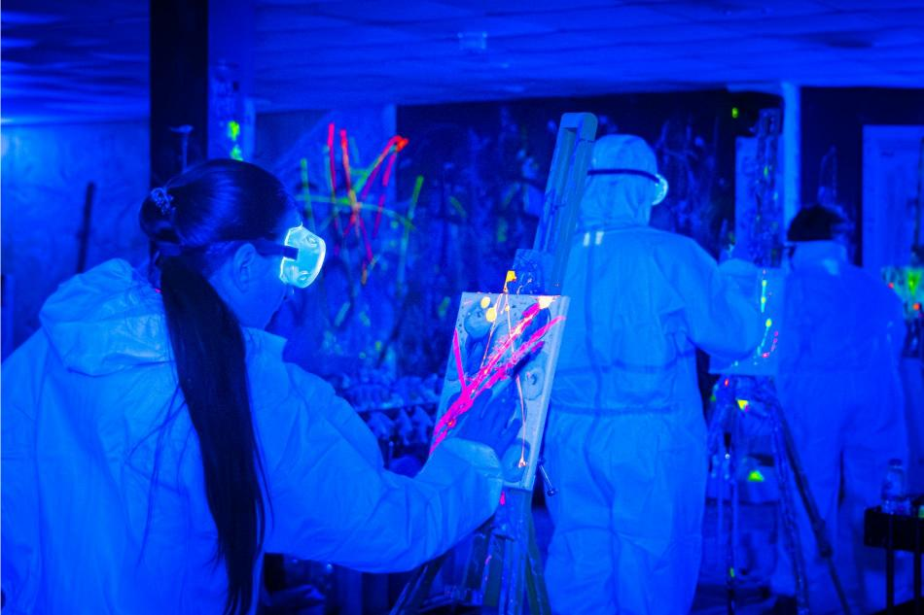
Adults often pick Neon. Splash sessions as a break from routine. Adults find the colour and physical movement a chance to stop thinking about work for an hour. Friends enjoy the shared energy in the room while couples often choose Neon and splash sessions as a date that feels different from a usual dinner out.
Younger visitors are welcome too. Children should be watched by an adult during Neon and splash sessions because the activity is self‑guided. The team can guide you on the option, for different ages when you book. Families can take part together. Everyone creates something at the same time, which makes the visit a shared memory.

Why Choose Rage Painting
Rage painting Worcester gives a way to let out feelings that other creative things don't offer. People show their emotions by moving and the final painting shows all that energy. The bright neon colors and the splashing style make the colors stand out and keep people from the first throw to the last one.
The way it works is easy too. All the things needed are there on the day. There is not much to get ready except making the booking. The session does not have an answer, which means people can try different things without being worried, about making mistakes.
Many people say the feeling of being stays with them after they leave the studio. The mix of moving, bright colors and having a painting makes the experience something they remember. That is why a lot of people come back with friends or family.

Group Neon Splash Sessions
Group sessions are a favored option for birthdays, parties and work events in Worcester. Group sessions with ten or more people receive a five percent discount, on their booking, which makes larger gatherings more affordable. Group sessions let each person paint without getting in the way of others so groups can share the neon and splash session while working on their canvases.

Teams and Celebrations
Teams often use rage painting to spend time outside the office. The session encourages laughter and friendly rivalry and there is no pressure to perform so everyone can enjoy rage painting freely.

Families and Friends
Families like to look at the canvases at the end because everyone makes something at the time. Friends think the energy, in the room is a way to have fun.

Booking Your Session
Booking a neon and splash session is easy. Start on the Splasherist website, where you can look at dates compare different session types and see current prices. Prices are listed per person so you can figure out the cost for your group before you decide to book.
You will need to provide your name, contact information the number of people coming and your chosen session type. Payment is done online. You get a confirmation once the booking is done. If you have any needs related to accessibility or questions about whether the session's suitable, for different ages talk to the studio before you finish booking.
When booking online the booking must pick any items because the booking cannot add them on the day of the visit. The booking system displays times clearly. The booking can pick a time that suits the plans. Checking the session type the extra items and the number of people, before confirming helps everything go smoothly.

From Arrival to Artwork
When you arrive the studio team greets you with a welcome. Arriving a minutes earlier lets you check in lock your belongings and slip on protective gear. The staff fit the gear for you making sure everything feels safe before you begin to paint.
When you are ready a host leads you into the studio. Tells you how the session will work. The canvas, paints and tools are ready. The timed session is self‑guided. You may throw, flick. Spray the paint in any order you choose and the neon colour will start to glow when the lights shift.
When the session ends step back. Admire the work you have made. Many guests find that their finished piece mirrors their energy. The canvas becomes yours to take home to display or to share with friends and family.

Start Your Neon Splash Journey
A neon and splash session is a way to spend time in Worcester. It uses colors moving around and creates a piece of art that works for people who are just starting out or who have more experience. No matter if you are looking for a day out a special event or a day, with a group the studio has everything you need to take part.
The staff is happy to answer any questions before you book and the welcoming environment makes every visitor feel comfortable when they arrive. At the end of each session there is a painting and a feeling of achievement that many people remember for a long time after.
Book your session today and find out how bright colors and moving freely can make a regular day in Worcester into something special.

